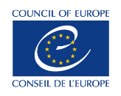
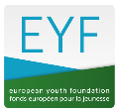
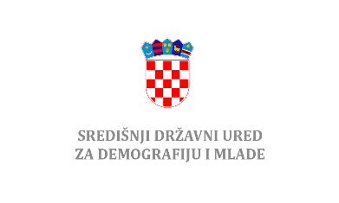

Introduction to the Council of Europe’s resources and EYF grants for youth organisations in the Republic of Croatia

Training session organised in co-operation with
Central State Office for Demography and Youth in the Republic of Croatia

17 – 19 May 2022, 9.00 – 13.00 (online)

Call for participants
Deadline: 6 May 2022

Introduction
Established in 1972, the European Youth Foundation (EYF) is an institution and a financial instrument of the Council of Europe’s youth sector. It provides financial support to local, national and international non-governmental youth organisations and networks for their local, national and international youth projects. The EYF is more than just a donor. It is a partner to youth organisations, supporting the exchange of good practices and high quality of youth projects.
The EYF, in collaboration with the Central State Office for Demography and Youth, is organising an information and training session for youth non-governmental organisations in Croatia. The session will focus on the Council of Europe youth sector priorities, educational tools and grant programmes. The session will also allow the participating youth organisations to share information on their work, their challenges and needs, and to explore further cooperation with the Council of Europe youth sector.
The session will take place online on 17-18-19 May 2022 (mornings only – see appended outline). The working language of the session will be English.
Who can participate?

If you are member of a youth NGO, active at local (municipality) or national level (country, region) this invitation is for you!

- You are aged between 18 and 30 (some exceptions for 30+ will be possible).
- You are engaged in youth projects: writing applications, implementing, reporting on projects.
- You work with and support young people and youth organisations.
What can you expect?

You will participate in an interactive session, informal discussions and practical workshops, ran by the EYF Secretariat. You will learn about the political context in which the Council of Europe operates, the EYF and the Council of Europe non-formal education and supporting tools. You will have the possibility to ask questions, participate and exchange on good practices with the organisers.

You will also be able to exchange with other participating organisations in Croatia, create new contacts and plan new partnerships.
This is a three-day (mornings) activity, and you will be expected to be with us through the full programme.

Selection and deadline for applications
You should be nominated by your organisation (see application forms), and send your application completed to the Central State Office for Demography and Youth by 6 May 2022 by means of electronic communication, to the following email addresses:
Marina.Maricic@demografijaimladi.hr
pisarnica-sdudm@demografijaimladi.hr
The selection of participants will be made based on the application files. For more information, please contact the Central State Office for Demography and Youth by means of electronic communication ( Marina.Maricic@demografijaimladi.hr , pisarnica-sdudm@demografijaimladi.hr ).

